Name: Bibek Bhandari

Student ID: 14338471

Course: 32606 Database Principles - Spring 2022

Question 1:

SELECT astroname, count(missionno) as Missions

FROM NASA2_Astronaut NATURAL JOIN NASA2_Assigned

WHERE projectname = 'Apollo'

GROUP BY astroname

HAVING count(missionno) > 1

ORDER BY astroname;

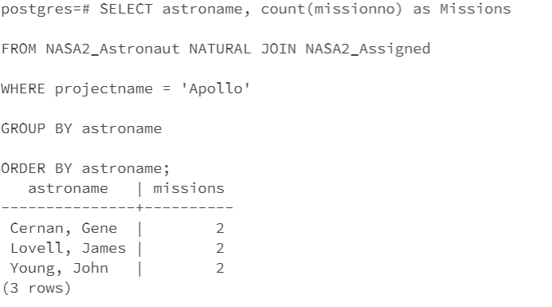

Questiion 2:

select missionno, launchyear, days from nasa2_mission where projectname = 'Shuttle' and days = (Select max(days) from nasa2_missio

n where projectname = 'Apollo');

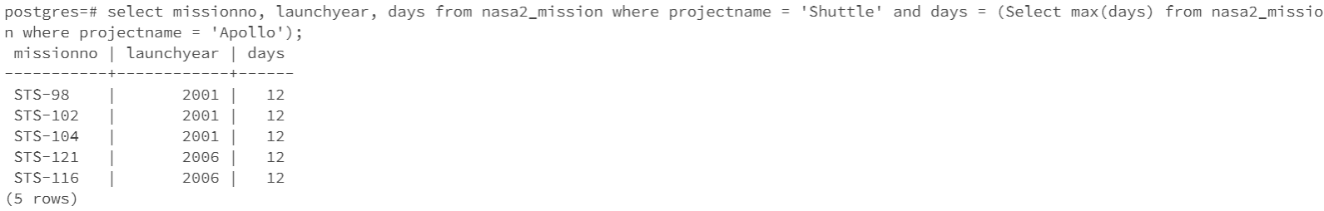

Question 3:

select a.astrono as Commander,b.astrono as Pilot, a.missionno from nasa2_assigned a, nasa2_assigned b where a.missionno = b.missionno and a.projectname = 'Shuttle' and a.role = 'Commander' and b.role='Pilot' and a.missionno like '%4' order by a.missionno;

